ITA0608-MACHINE LEARNING
UNIT -02

CO-02
ASSIGNMENT -02

Q: Compare batch, stochastic, and mini-batch gradient descent in the context of training abackpropagation network on large-scale climate sensor data for extreme weather prediction.
(SDG 13 – Climate Action)

SUBMITTED BY:
S.Venkatesh(192312109)

Comparison of Batch, Stochastic, and Mini-Batch Gradient Descent in Training a Backpropagation Neural Network for Large-Scale Climate Sensor Data
Introduction
Climate change has become one of the major global challenges, causing frequent floods, cyclones, droughts, heat waves, and other extreme weather events. Predicting these events accurately is essential for protecting lives, agriculture, and infrastructure. Artificial Intelligence (AI), especially Artificial Neural Networks (ANNs), plays an important role in analyzing large volumes of climate sensor data and forecasting weather conditions.
A Backpropagation Neural Network (BPNN) is widely used for weather prediction because it learns from historical climate data by minimizing prediction errors. During training, Gradient Descent algorithms update the network weights to improve prediction accuracy. The three commonly used optimization techniques are Batch Gradient Descent, Stochastic Gradient Descent (SGD), and Mini-Batch Gradient Descent.
Objective
The objectives of this study are to:
- Understand the Backpropagation Neural Network.
- Compare Batch, Stochastic, and Mini-Batch Gradient Descent algorithms.
- Analyze their performance for large-scale climate sensor datasets.
- Identify the most suitable optimization method for extreme weather prediction.
- Demonstrate the contribution of AI towards SDG 13 – Climate Action.
Backpropagation Neural Network
A Backpropagation Neural Network is a supervised learning algorithm that consists of an input layer, one or more hidden layers, and an output layer. Climate sensor data such as temperature, humidity, rainfall, wind speed, and atmospheric pressure are provided as inputs. The network processes these inputs, predicts future weather conditions, calculates the prediction error, and updates the weights using Gradient Descent until the error becomes minimal.

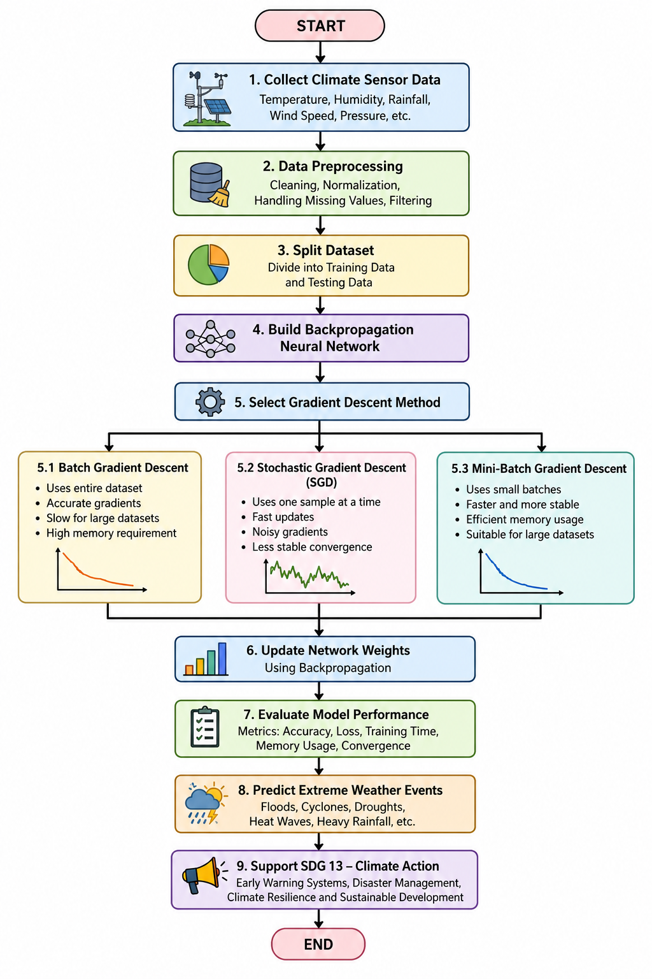
WORKFLOW AND METHODOLOGY
Gradient Descent Techniques
1. Batch Gradient Descent
Batch Gradient Descent uses the entire training dataset to calculate the error before updating the network weights.
Advantages
- Produces stable and accurate gradient estimates.
- Smooth convergence toward the minimum error.
- Suitable for small datasets.
Disadvantages
- Very slow for large climate datasets.
- Requires high computational power and memory.
- Not suitable for real-time weather prediction.
2. Stochastic Gradient Descent (SGD)
Stochastic Gradient Descent updates the weights after processing each training sample.
Advantages
- Faster learning process.
- Low memory requirement.
- Suitable for continuously arriving sensor data.
Disadvantages
- Gradient updates are noisy.
- Training may fluctuate before reaching the optimum solution.
- Less stable than Batch Gradient Descent.
3. Mini-Batch Gradient Descent
Mini-Batch Gradient Descent divides the dataset into small batches (typically 32–256 samples) and updates the weights after each batch.
Advantages
- Faster convergence than Batch Gradient Descent.
- More stable than Stochastic Gradient Descent.
- Efficient GPU utilization.
- Suitable for deep learning applications.
Disadvantages
- Batch size must be selected carefully.
- Requires moderate memory resources.
Comparison of Gradient Descent Methods
Parameter | Batch Gradient Descent | Stochastic Gradient Descent | Mini-Batch Gradient Descent
Data Used | Entire dataset | One sample | Small batches
Speed | Slow | Very Fast | Fast
Memory Requirement | High | Low | Moderate
Convergence | Stable | Noisy | Stable
Accuracy | High | Moderate | High
Large Dataset Performance | Poor | Good | Excellent
Real-Time Learning | No | Yes | Yes
Best Application | Small datasets | Online learning | Deep learning and large datasets

Application in Climate Sensor Data
Climate monitoring systems collect data from thousands of sensors measuring temperature, humidity, rainfall, wind speed, atmospheric pressure, and solar radiation. These datasets are extremely large and continuously growing.
A Backpropagation Neural Network trained with Mini-Batch Gradient Descent can efficiently learn weather patterns from these datasets. The trained model predicts heavy rainfall, floods, cyclones, droughts, and heat waves more accurately than traditional statistical methods. Faster model training also enables real-time weather forecasting and early warning systems.
Contribution to SDG 13 – Climate Action
The use of Artificial Intelligence in weather prediction directly supports Sustainable Development Goal 13 (Climate Action) by:
- Improving early warning systems for natural disasters.
- Reducing damage caused by floods and cyclones.
- Supporting climate-resilient agriculture.
- Assisting governments in disaster preparedness.
- Enhancing environmental monitoring and sustainable development.
Conclusion
Batch Gradient Descent provides accurate learning but is computationally expensive for large datasets. Stochastic Gradient Descent offers faster updates but produces unstable convergence due to noisy gradient estimates. Mini-Batch Gradient Descent combines the advantages of both approaches by providing faster convergence, improved stability, efficient memory usage, and high prediction accuracy. Therefore, Mini-Batch Gradient Descent is the most suitable optimization technique for training Backpropagation Neural Networks on large-scale climate sensor data for extreme weather prediction. Its ability to improve forecasting accuracy contributes significantly to SDG 13 – Climate Action by supporting disaster risk reduction and climate resilience.
References
- Simon Haykin, Neural Networks and Learning Machines, Pearson.
- Christopher M. Bishop, Pattern Recognition and Machine Learning, Springer.
- Ian Goodfellow, Yoshua Bengio, and Aaron Courville, Deep Learning, MIT Press.
- United Nations, Sustainable Development Goal 13 – Climate Action.

